

DEPARTMENT OF COMPUTER SCIENCE AND ENGINEERING

DATABASE MANAGEMT LAB MANUAL (Integrated)

(P21CS404)

Preface

A database management system (DBMS) is a computer application software designed to effectively handle and maintain data. In today's context, there is a growing need for automated systems that can manage, modify, and update data with precision. A DBMS accomplishes this task in a robust, accurate, and non-redundant manner. Structured Database Management Systems (DBMS) based on relational and other models have traditionally served as the foundation for such databases. As a result, commercial systems like Oracle, Microsoft SQL Server, and Sybase have risen to prominence, while open-source and free domain solutions such as MySQL and PostgreSQL lead the way. This course enables students to apply the conceptual design model to create solutions for real-world requirements. It provides students with a solid understanding of Database Concepts, allowing them to analyze various constraints when populating a database and explore different operational concepts of DBMS to determine the most appropriate documentation pattern.

**DBMS Lab set**

|  |  |
| --- | --- |
| **Sl.No** | **Experiments** |
| **1.** | Create an ER diagrams **Company Database system** and **Banking Database System using** drawio tool. |
| **2.** | i. Consider the **Company database** and create the below tables by properly specifying the primary keys and the foreign keys.  **Employee** (Fname: varchar, Minit: Char, Lname: varchar, ssn:int, Bdate: Date, Address: varchar, Sex: char, salary: decimal,Super_ssn:int, DNO:int)  **Department** (Dname: varchar, Dnumber: int, mgr_ssn: int, mgr_start_date: date)  **Dept_location** (Dnumber: int, Dlocation: varchar)  **Project** (pname: varchar, pnumber: int, plocation: varchar, dnum:int)  **Works_on** (Essn: int, pno:int, hours: decimal)  **Dependent** (Essn: char, dependent_name: varchar, sex: char, Bdate: date, relationship: varchar)  ii. Insert at least five tuples in each relation. |
| **3.** | i. Retrieve the name and address of all employees who work for the ‘Research’ department.  ii. For every project located in ‘Stafford’, list the project number, the controlling department number, and the department manager’s last name, address, and birth date.  iii. For each employee, retrieve the employee’s first and last name and the first and last name of his or her immediate supervisor.  iv. Make a list of all project numbers for projects that involve an employee whose last name is ‘Smith’, either as a worker or as a manager of the department that controls the project.  v. Retrieve all employees whose address is in Houston, Texas.  vi. Retrieve all employees in department 5 whose salary is between $30,000 and $40,000.  **Execute above quires for the Company database defined in Unit-II.** |
| **4.** | i. Retrieve the names of all employees who do not have supervisors.  ii. Retrieve the name of each employee who has a dependent with the same first name and is the same gender as the employee  iii. Retrieve the names of employees who have no dependents.  iv. List the names of managers who have at least one dependent.  v. Retrieve the Social Security numbers of all employees who work on project numbers 1, 2, or 3.    vi. Find the sum of the salaries of all employees of the ‘Research’ department, as well as the maximum salary, the minimum salary, and the average salary in this department.  vii. For each department, retrieve the department number, the number of employees in the department, and their average salary.  **Execute above quires for the Company database defined in Unit-II.** |
| **5.** | Consider the following database for a Banking enterprise:  **BRANCH** (branch-name: string,branch-city: string,assets: real)  **ACCOUNT** (accno:int,branch-name: string,balance: real)  **DEPOSITOR** (customer-name: string,accno:int)  **CUSTOMER** (customer-name: string,customer-street: string,city:string)  **LOAN** (loan-number:int,branch-name: string,loan-number-int)  **BORROWER** (customer-name: string,customer-street: string,city: string)  1) Create the above tables by properly specifying the primary and foreign keys  2) Enter 5 tuples for each relation  3) Find all the customers who have atleast two accounts at the main branch  4) Find all the customers who have an account at all the branches located in a specified city  5) Demonstrate how you delete all account tuples at every branch located in a specified city |

**Basic concepts**

**Schema**

A database schema is considered the “blueprint” of a database which describes how the data may relate to other tables or other data models. However, the schema does not actually contain data. A sample of data from a database at a single moment in time is known as a database instance.

Types of database schemas

While the term schema is broadly used, it is commonly referring to three different schema types—a conceptual database schema, a logical database schema, and a physical database schema.

* **Conceptual schemas** offer a big-picture view of what the system will contain, how it will be organized, and which business rules are involved. Conceptual models are usually created as part of the process of gathering initial project requirements.
* **Logical database schemas** are less abstract, compared to conceptual schemas. They clearly define schema objects with information, such as table names, field names, entity relationships, and integrity constraints—i.e. any rules that govern the database. However, they do not typically include any technical requirements.
* **Physical database schemas** provide the technical information that the logical database schema type lacks in addition to the contextual information, such as table names, field names, entity relationships, et cetera. That is, it also includes the syntax that will be used to create these data structures within disk storage.
* **Three schema architecture:**

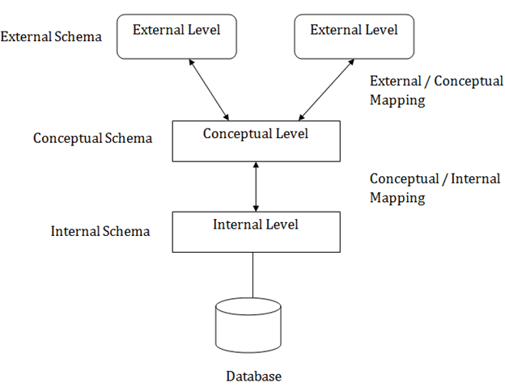

Objectives of three schema architecture:

* Different users need different views of the same data.
* The approach in which a particular user needs to see the data may change over time.
* The users of the database should not worry about the physical implementation and internal workings of the database such as data compression and encryption techniques, hashing, optimization of the internal structures etc.
* All users should be able to access the same data according to their requirements.
* DBA should be able to change the conceptual structure of the database without affecting the user's
* Internal structure of the database should be unaffected by changes to physical aspects of the storage.

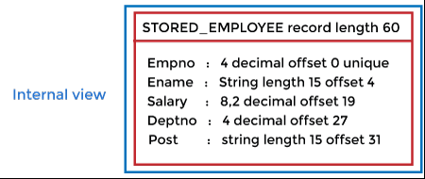

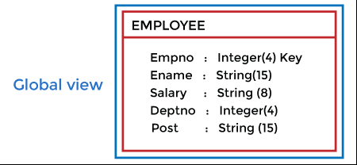

C:\Users\Innovation Lab\Desktop\2022-2023 even sem\DBMS\dbms-three-schema-architecture4.png

**ER diagram**

An Entity Relationship (ER) Diagram is a type of flowchart that illustrates how “entities” such as people, objects or concepts relate to each other within a system. ER Diagrams are most often used to design or debug relational databases in the fields of software engineering, business information systems, education and research. Also known as ERDs or ER Models, they use a defined set of symbols such as rectangles, diamonds, ovals and connecting lines to depict the interconnectedness of entities, relationships and their attributes. They mirror grammatical structure, with entities as nouns and relationships as verbs.

**Components of ER diagram** 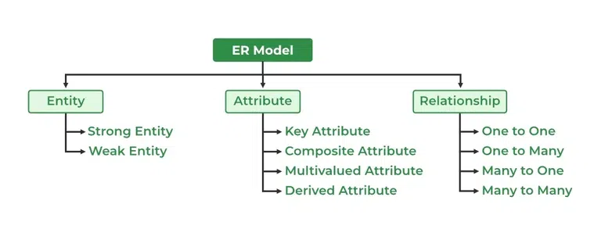

**Symbols used in ER diagram**

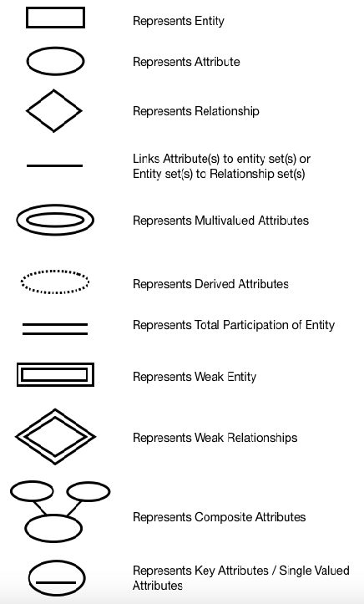

**Experiment 1**

**Create ER diagram for company database using Drawio.**

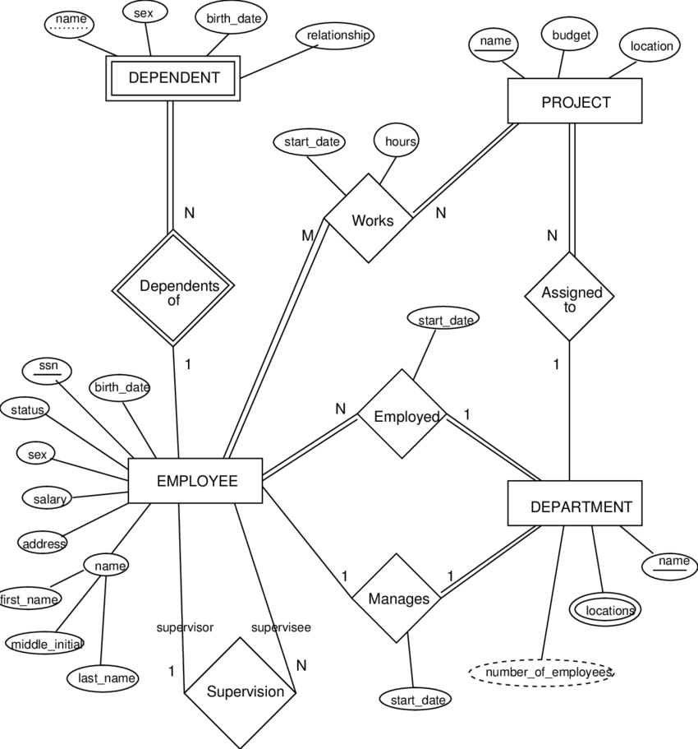

**Create ER diagram for Bank database using Drawio.**

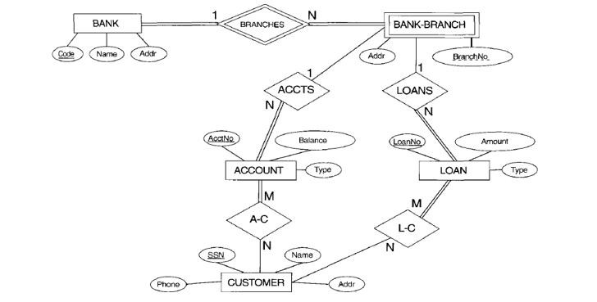

**Basic SQL commands**

**To Create database:** CREATE database_name;

**Drop command to remove existing database:** DROP DATABASE IF EXISTS data base_name;

**To use created database:** USE database_name;

**To list tables in a database:** SHOW tables;

**Drop command to remove existing table:** DROP DATABASE IF EXISTS table_name;

**To describe a database:** DESC table_name;

**PROBLEM STATEMENT**

2) Consider the **Company database** and create the below tables by properly specifying the primary keys and the foreign keys.

**Employee** (Fname: varchar, Minit: Char, Lname: varchar, ssn:int, Bdate: Date, Address: varchar, Sex: char, salary: decimal,Super_ssn:int, DNO:int)

**Department** (Dname: varchar, Dnumber: int, mgr_ssn: int, mgr_start_date: date)

**Dept_location** (Dnumber: int, Dlocation: varchar)

**Project** (pname: varchar, pnumber: int, plocation: varchar, dnum:int)

**Works_on** (Essn: int, pno:int, hours: decimal)

**Dependent** (Essn: char, dependent_name: varchar, sex: char, Bdate: date, relationship: varchar)

**CREATE TABLE DEPARTMENT** (

dname varchar(25) not null,

dnumber int not null,

mgrssn char(9),

mgrstartdate date ,

CONSTRAINT pk_Department primary key (dnumber),

CONSTRAINT uk_dname UNIQUE (dname));

**CREATE TABLE EMPLOYEE** (

fname varchar(15) not null,

minit varchar(1),

lname varchar(15) not null,

ssn char(9) not null,

bdate date,

address varchar(50),

sex char,

salary decimal(10,2),

superssn char(9),

dno int not null ,

CONSTRAINT pk_employee primary key (ssn),

CONSTRAINT emp_superssn foreign key(superssn)references EMPLOYEE(ssn)

On delete not NULL on update cascade,

CONSTRAINT fk_employee_department foreign key (dno) references DEPARTMENT(dnumber)

on delete cascade on update cascade);

**ALTER TABLE DEPARTMENT**

ADD CONSTRAINT Dept_mgrfk

foreign key (mgrssn)references EMPLOYEE(ssn) on delete cascade ON UPDATE CASCADE ;

**CREATE TABLE DEPENDENT** (

essn char(9),

dependent_name varchar(15),

sex char,

bdate date,

relationship varchar(8),

CONSTRAINT pk_essn_dependent_name primary key (essn,dependent_name),

CONSTRAINT fk_dependent_employee foreign key (essn) references EMPLOYEE(ssn) );

**CREATE TABLE DEPT_LOCATIONS** (

dnumber int,

dlocation varchar(15),

CONSTRAINT pk_dept_locations primary key (dnumber,dlocation),

CONSTRAINT fk_deptlocations_department foreign key (dnumber) references DEPARTMENT(dnumber) on delete cascade on update cascade

);

**CREATE TABLE PROJECT** (

pname varchar(25) not null,

pnumber int,

plocation varchar(15),

dnum int not null,

CONSTRAINT ok_project primary key (pnumber),

CONSTRAINT uc_pnumber unique (pname),

CONSTRAINT fk_project_department foreign key (dnum) references DEPARTMENT(dnumber)

);

**CREATE TABLE WORKS_ON** (

essn char(9),

pno int,

hours decimal(4,1),

CONSTRAINT pk_worksOn primary key (essn,pno),

CONSTRAINT fk_workson_employee foreign key (essn) references EMPLOYEE(ssn),

CONSTRAINT fk_workson_project foreign key (pno) references PROJECT(pnumber)

);

ii. Insert at least five tuples in each relation.

**Syntax of INSERT command:** INSERT INTO table_name VALUES(list of values corresponding to each attribute);

**Ex:** INSERT INTO DEPARTMENT VALUES ('Research','5','333445555','1978-05-22');

3 )

i.**Retrieve the name and address of all employees who work for the ‘Research’ department.**

select e.fname,e.address from employee e, department d where d.dname="Research" and d.dnumber = e.dno;

ii. **For every project located in ‘Stafford’, list the project number, the controlling department number, and the department manager’s last name, address, and birth date.**

select p.pnumber,p.dnum,e.lname,e.address,e.bdate from project p, department d, employee e where p.plocation="Stafford" and p.dnum= d.dnumber and d.mgrssn=e.ssn;

iii. **For each employee, retrieve the employee’s first and last name and the first and last name of his or her immediate supervisor.**

select e.fname,e.lname,s.fname,s.lname from employee as e, employee as s where s.superssn=e.ssn;

**iv. Make a list of all project numbers for projects that involve an employee whose last name is ‘Smith’, either as a worker or as a manager of the department that controls the project.**

(select distinct pnumber from project,department,employee where dnum=dnumber and mgrssn=ssn and lname="Smith")

union

(select distinct pnumber from project,works_on,employee where pnumber=pno and essn=ssn and lname="Smith");

**v. Retrieve all employees whose address is in Houston, Texas.**

select fname,mname,lname from employee where address="Houston,Texas";

**vi. Retrieve all employees in department 5 whose salary is between $30,000 and $40,000.**

select * from employee where dno=5 and salary >=30000 and salary <=40000;

***4)* PROBLEM STATEMENT**

**i** **.Retrieve the names of all employees who do not have supervisors.**

SQL> select e.first_name,e.last_name from employee as e where NOT exists(select

‘*’from employee as s where e.superssn=s.ssn);

**ii. Retrieve the name of each employee who has a dependent with the same first name and is the same gender as the employee.**

SQL> select e.first_name,e.last_name from employee as e (select ‘*’ from dependent

d where e.fname=d.dependent_name and e.sex=d.sex and e.ssn=d.essn);

**iii. Retrieve the names of employees who have no dependents.**

SQL> select e.first_name,e.last_name from employee as e where NOT exists(select ‘*’ from dependent as d where e.ssn=d.ssn);

**iv. List the names of managers who have at least one dependent.**

SQL> select b.first_name,b.last_name from employee b where (select count(*) from

dependent where b.ssn=e.ssn)>=1;

**v. Retrieve the Social Security numbers of all employees who work on project numbers 1, 2, or 3.**

SQL> select e.ssn from employee as e where e.ssn in(select essn from works_on

where pnumber=1or pnumber=2 or pnumber=3);

**vi. Find the sum of the salaries of all employees of the ‘Research’ department, as well as the maximum salary, the minimum salary, and the average salary in this department.**

SQL> select sum(salary),max(salary),min(salary),avg(salary) from

employee.department where dname=‘Research’ and dno=dnumber;

**vii. For each department, retrieve the department number, the number of employees in the department, and their average salary.**

SQL> select dno,count(*),avg(salary) from employee group by dno;

**PROBLEM STATEMENT**

5. Consider the following database for a banking enterprise

**BRANCH** (branch***_***name: string, branch_city: string, assets: real)

**ACCOUNT** (accno: int, branch_name: string, balance: real)

**CUSTOMER** (customer_name: string, customer_street: string, customer_city: string)

**DEPOSITOR** (customer_name: string, accno: int)

**LOAN** (loan_number: int, branch_name: string, amount: real)

**BORROWER** (customer_name: string, loan_number: int)

i) Create the above tables by properly specifying the primary keys

and the foreign keys.

ii) Enter atleast five tuples for each relation.

iii) Find all the customers who have atleast two accounts at the ***Main*** branch.

iv) Find all the customers who have an account at ***all*** the branches located in a specific city.

v) Demonstrate how you delete all account tuples at every branch located in a specific city.

**TABLE CREATION**

SQL> create table branch

(

branch_name varchar(25) primary key,

branch_city varchar(20) not null,

assets decimal(10,2) not null

);

Table created.

**TABLE DESCRIPTION**

SQL> describe branch;

Name Null? Type

-----------------------------------------------------------------------------

BRANCH_NAME NOT NULL VARCHAR2(25)

BRANCH_CITY NOT NULL VARCHAR2(20)

ASSETS NOT NULL NUMBER(10,2)

**INSERTING TUPLES**

SQL> insert into branch values('jaynagar’,'bangalore','15000000');

SQL>insert into branch values(‘basavanagudi’,’bangalore’,’25000000’);

SQL>insert into branch values(‘noida’,’delhi’,’50000000’);

SQL>insert into branch values(‘marine drive’,’mumbai’,’40000000’);

SQL>insert into branch values(‘grren park’,’delhi’,’30000000’);

BRANCH_NAME BRANCH_CITY ASSETS

------------------------------------------------------------------------------------

Jaynagar bangalore 15000000

basavanagudi bangalore 25000000

noida delhi 50000000

marine drive mumbai 40000000

green park delhi 30000000

**TABLE CREATION**

SQL> create table account

(

accno int primary key,

branch_name varchar(25) not null,

balance decimal(10,2) not null,

foreign key(branch_name) references branch(branch_name)

);

Table created.

**TABLE DESCRIPTION**

SQL> describe account;

Name Null? Type

------------------------------------------------------------------------------------

ACCNO NOT NULL NUMBER(38)

BRANCH_NAME NOT NULL VARCHAR2(25)

BALANCE NOT NULL NUMBER(10,2)

**INSERTING TUPLES**

SQL>insert into account values(‘123’,’jaynagar’,’25000’);

SQL>insert into account values(‘156’,’jaynagar’,’30000’);

SQL>insert into account values(‘456’,‘basavanagudi’,’15000’);

SQL>insert into account values(‘789’,‘noida’,’25000’);

SQL>insert into account values(‘478’,’marine drive’,’48000’);

SQL>insert into account values(‘778’,’green park’,’60000’);

SQL>insert into account values(‘189’,’basavanagudi’,’48888’);

SQL> select * from account;

ACCNO BRANCH_NAME BALANCE

---------- ------------------------- ------------------------------------

123 jaynagar 25000

156 jaynagar 30000

456 basavanagudi 15000

789 noida 25000

478 marine drive 48000

778 green park 60000

189 basavanagudi 48888

**TABLE CREATION**

SQL> create table customer

(

customer_name varchar(25) primary key,

customer_street varchar(25) not null,

customer_city varchar(25) not null

);

Table created.

**TABLE DESCRIPTION**

SQL> describe customer;

Name Null? Type

-----------------------------------------------------------------------------

CUSTOMER_NAME NOT NULL VARCHAR2(25)

CUSTOMER_STREET NOT NULL VARCHAR2(25)

CUSTOMER_CITY NOT NULL VARCHAR2(25)

**INSERTING TUPLES**

SQL> insert into customer values(‘ramu’,’jaynagar’,’bangalore’);

SQL> insert into customer values(‘kumar’,’basavanagudi’,’bangalore’);

SQL> insert into customer values(‘john’,’noida’,’delhi’);

SQL> insert into customer values(‘mike’,’marine drive’,’mumbai’);

SQL> insert into customer values(‘sachin’,’green park’,’delhi’);

SQL> select * from customer;

CUSTOMER_NAME CUSTOMER_STREET CUSTOMER_CITY

-------------------------------------------------------------------------------------------------------

ramu jaynagar bangalore

kumar basavanagudi bangalore

john noida delhi

mike marine drive mumbai

sachin green park delhi

**TABLE CREATION**

SQL> create table depositor

(

customer_name varchar(25) not null,

accno int not null,

foreign key (customer_name) references customer (customer_name)

foreign key(accno) references account(accno) on delete cascade

);

Table created.

**TABLE DESCRIPTION**

SQL> describe depositor;

Name Null? Type

-----------------------------------------------------------------------------

CUSTOMER_NAME NOT NULL VARCHAR2(25)

ACCNO NOT NULL NUMBER(38)

**INSERTING TUPLES**

SQL> insert into depositor values(‘ramu’,’123’);

SQL> insert into depositor values(‘ramu’,’156’);

SQL> insert into depositor values(‘ramu’,’189’);

SQL> insert into depositor values(‘kumar’,’456’);

SQL> insert into depositor values(‘john’,’789’);

SQL> insert into depositor values(‘mike’,’478’);

SQL> insert into depositor values(‘sachin’,’778’);

SQL> select *from depositor;

CUSTOMER_NAME ACCNO

--------------------------------------------------

ramu 123

ramu 156

ramu 189

kumar 456

john 789

mike 478

sachin 778

**TABLE CREATION**

SQL> create table loan

(

loan_number int primary key,

branch_name varchar(25) not null,

amount decimal(10,2) not null,

foreign key(branch_name) references branch (branch_name)

);

Table created.

**TABLE DESCRIPTION**

SQL> describe loan;

Name Null? Type

--------------------------------------------------------------------------

LOAN_NUMBER NOT NULL NUMBER(38)

BRANCH_NAME NOT NULL VARCHAR2(25)

AMOUNT NOT NULL NUMBER(10,2)

**INSERTING TUPLES**

SQL> insert into loan values(‘1111’,’jaynagar’,’250000’);

SQL> insert into loan values(‘2222’,’basavanagudi’,’350000’);

SQL> insert into loan values(‘3333’,’noida’,’150000’);

SQL> insert into loan values(‘4444’,’marine drive’,’1500000’);

SQL> insert into loan values(‘5555’,’green park’,’7500000’);

SQL> select *from loan;

LOAN_NUMBER BRANCH_NAME AMOUNT

-----------------------------------------------------------------------------------

1111 jaynagar 250000

2222 basavanagudi 350000

3333 noida 150000

4444 marine drive 1500000

5555 green park 7500000

**TABLE CREATION**

SQL> create table borrower

(

customer_name varchar(25) not null,

loan_number int not null,

foreign key(customer_name) references customer (customer_name),

foreign key (loan_number) references loan (loan_number),

primary key(customer_name,loan_number)

);

Table created.

**TABLE DESCRIPTION**

SQL> describe borrower;

Name Null? Type

-----------------------------------------------------------------------------

CUSTOMER_NAME NOT NULL VARCHAR2(25)

LOAN_NUMBER NOT NULL NUMBER(38)

**INSERTING TUPLES**

SQL> insert into borrower values(‘ramu’,’1111’);

SQL> insert into borrower values(‘kumar’,’2222’);

SQL> insert into borrower values(‘john’,’3333’);

SQL> insert into borrower values(‘mike’,’4444’);

SQL> insert into borrower values(‘sachin’,’5555’);

SQL> select *from borrower;

CUSTOMER_NAME LOAN_NUMBER

-------------------------------------------------------------

ramu 1111

kumar 2222

john 3333

mike 4444

sachin 5555

**QUERIES**

**1. Find all the customers who have atleast two accounts at the *Main* branch.**

SQL> select distinct(customer_name), count(*)

from account a, depositor d

where a.accno=d.accno

and d.accno in (select accno from account

where branch_name=’jaynagar’)

group by d.customer_name

having count(*)>=2;

**RESULT**

CUSTOMER_NAME COUNT(*)

------------------------------------------------------

ramu 2

**EXPLANATION**

The above query is similar to a SELECT-JOIN-PROJECT sequence of relational algebra operations and such queries are called select-join queries. In the WHERE clause, branch_name = ‘jaynagar’ specifies the main branch and a.accno = d.accno is a join condition for the join operation on the two relations account and depositor. Then the GROUP BY clause is used to sub-group the tuples based on the grouping attributes branch_name and customer_name. The HAVING clause provides a condition count (*) >= 2 on the groups of tuples. Only the groups that satisfy the condition are retrieved in the result of the query.

**2. Find all the customers who have an account at all the branches located in a specific city.**

SQL> select d.customer_name

from account a, depositor d, branch b

where b.branch_name=a.branch_name and a.accno=d.accno

and b.branch_city=’bangalore’

having count(distinct b.branch_name)=(select count(branch_name)

from branch

where branch_city=’bangalore’)

group by customer_name;

**RESULT**

CUSTOMER_NAME

-------------------------

ramu

**EXPLANATION**

The inner query counts the number of branches in ‘bangalore’ which is used to compare with the number of branches in Bangalore in which a customer has accounts. We join the account, depositor and branch tables by specifying the appropriate join conditions and selecting only those tuples having branches in Bangalore grouped by the customer name.

**3. Demonstrate how you delete all account tuples at every branch located in a specific city.**

SQL> delete from account

where branch_name in (select branch_name

from branch

where branch_city='delhi');

2 rows deleted. **RESULT**

SQL> select *from account;

ACCNO BRANCH_NAME BALANCE

-----------------------------------------------------------------------

123 jaynagar 25000

156 jaynagar 30000

456 basavanagudi 15000

478 marine drive 48000

189 basavanagudi 48888

SQL> select *from depositor;

CUSTOMER_NAME ACCNO

------------------------------------------------

ramu 123

ramu 156

ramu 189

kumar 456

mike 478

**EXPLANATION**

The nested query selects the tuples that satisfy the selection condition branch_city = ‘delhi’ from the relation branch .The IN operator compares the subtuple of value branch_name for each tuple in account relation with the tuples produced by the nested query. Finally, the selected tuples are deleted from the account relation. Here the account tuples containing the branches in delhi, i.e, in noida and green park are deleted. Also, since depositor references the accno from the account relation, for the accno deleted from the account table, corresponding tuples containing the same accno in depositor relation are deleted.